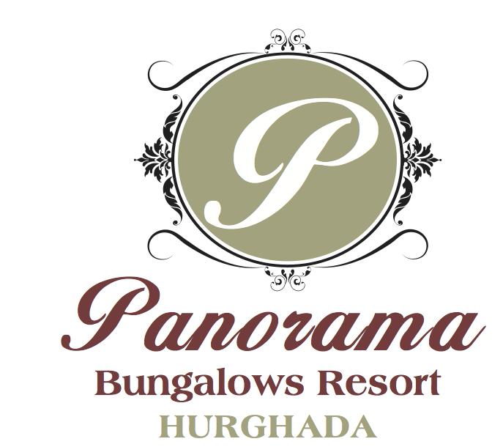

Dear Guest,
Thank you for choosing Panorama Bungalows Resort Hurghada to spend your vacation.
Panorama Bungalows Resort is offering you a relaxing stay in charming atmosphere.
Please take note of the following information & All inclusive system

Air Conditioning
Individually controlled. To get the air condition working, please place the power saver attached to the key ring into the slot next to the Room door.

All-Inclusive – Bracelet
On arrival Day, you will receive an All-Inclusive bracelet. You should wear it during your stay. This will entitle you for All Inclusive privileges

Beach and Swimming pool Towels
Beach and Swimming pool Towel cards will be handed out from the reception upon check in, to receive towels from the Recreation centre at the beach / pool.
Please return the towels back to the towel centre till 17:00 o'clock, to receive them back clean the next morning.

Bars
Our All-inclusive offer includes all local alcoholic beverages & Snacks 24 Hours.
The opening hours of our Bars are:

Pool Bar 10:00 – 23:00h
Beach Bar 10:00 – Sunset
Lobby Bar (Irish Bar) 24 Hours Soft and Hard All Inclusive included snaks.
Gelato Bar 10:00 – Sunset
Breakfast & Lunchbox
A breakfast and lunch bag for your excursions can be ordered for the next day at the Reception before 21:00 h.

Departure
On departure day please leave your room at 12:00h and remember to hand over the key, towel cards and All-inclusive bracelet to the Reception, as well as settling your account.
(All Inclusive program ends at 12:00h)

Dress Code & Non Smoking
Swimming wear and smoking is not allowed in the restaurants.

Disco Club
Our Panorama disco is included in all inclusive programs (operating from 23:00o'clock)

Electricity & Voltage
The voltage at the hotel is 220-240 V. When you enter the room, please place your key tag in the slot of the power saver.

Entertainment & Sports
A big variety of sports and entertainment awaits you! Your PANORAMA Entertainment Team would like to inform you
about our sports and activities, which are included in our “All-inclusive’’ program and about our available different
sport courses. Please check the info boards with our daily program from Aerobics to Shows.
PLEASE NOTE: THE HOTEL CANNOT BE HELD RESPONSIBLE FOR ANY SPORT ACCIDENTS.
Some entertainment might be against extra charge

Excursions
A big variety of excursions are offered through your tour operator. Please find the consulting hours on the info board of your Tour operator, if you have any further questions please contact the Reception.

Kids Club
Your children from 03 to 12 years available every day from10:00 till 12:00 & 15:00 till 17:00

Kite school
Enjoy with the professional kit school at the beach ( against extra charge)

Laundry
We offer a laundry service at our hotel. Please take note of the price and schedule for collection from our laundry list
which you can find in the cupboard. Laundry bag is available at the room

Lost key & towel Card
In case of loss of a towel card the amount of 20 $ will be charged to your room account
In case of loss of the room key the amount of 40 $ will be charged to your room account

Massage
Please book your massage direct at the Spa Centre. Prices and opening hours are displayed at the Spa centre. For information, please visit the Spa or dial 54050

Pharmacy / Doctor
A pharmacy is situated inside the hotel. A doctor is available 24 hours on call. In case of require, please contact the reception.

Pool& Water slides
The pools and water slides can be used from 08:00h –17:00h.

Restaurants & Meals
The opening hours of our Restaurants are:
Breakfast Main Restaurant 07:00 – 10:00h
Late Breakfast Pool bar 10:00 – 11:30h
Ice Cream Gelato Bar 10:00- 17:00
Lunch Main Restaurant 12:00 – 15:00h
Lunch Mini Buffet, Salads Pool bar 12:00 – 14:00h
Hot Snacks Pool bar 16:00 – 17:00h
Fruit Corner Pool bar 14:00 – 16:00h
Aperitif time pool bar 17:00- 19:00
Dinner Main Restaurant 18:00 – 21:00h
(Full daily different themes of international buffets and live cocking & BBQ at the terrace)
Late Dinner Mongolian Restaurant 22:00 – 05:00
A la Carte Restaurant (Mongolian Restaurant) is included in All-inclusive concept free of charge once per week
A la Carte Restaurant (Fish Restaurant located at the beach) is included in All-inclusive concept free of charge once
Per week
For reservation kindly contact 676 (Guest Relation) one day in advance from 10:00 till 13:00

According to our hotel policy is not allowed to take any food out from the restaurants due to hygienic reasons!

Safe
A safe box is available in your room free of charge.
PLEASE NOTE: THE HOTEL CANNOT BE HELD RESPONSIBLE FOR ANY VALUABLES LEFT OUTSIDE THE SAFE.

Shopping centre
In our shopping centre are different souvenir shops and a Mini market situated.

Taxi Service
A Taxi Service is available next to the Reception.

Telephone and Fax
Contact the telephone operator by dialling “0”. The operator can also send faxes.
TV
A TV set with satellite receivers with an international variety of programmes is available in your room.
Wake-up call
Please contact the Operator on “0” for a wake-up call.

Out of All Inclusive Concepts:
* Fresh juices, Espresso, Turkish coffee and any other outlet that has not been mentioned above is not part of the All inclusive program
* Mini Bar (soft drinks, water, chips, beer, juice, chocolates) and Room Service is not included
* Any alcoholic beverage consumption after 23:00hrs till 10:00 will be charged direct to guest's bill.

The whole Panorama team will exert on arranging your stay as comfortable and restful as possible.
Should you have any further questions or wishes please feel free to contact our reception by telephone no. 666 or Guest Relation team by telephone no. 676 anytime, so that we can fulfil your requests immediately. We would like you to feel home as our Panorama slogan “Welcome Home” shall become real

