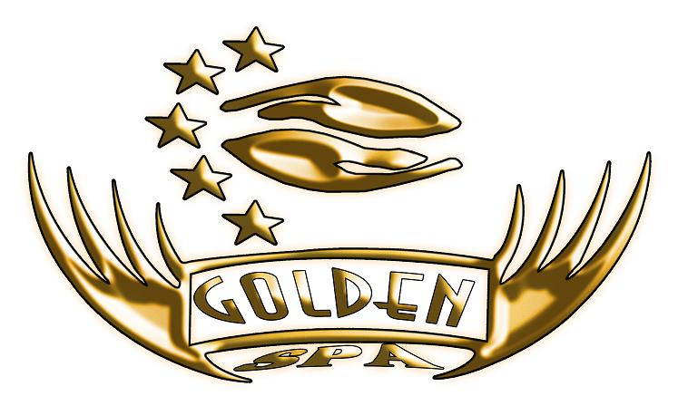

(90 min)
450LE 80 $ 60€
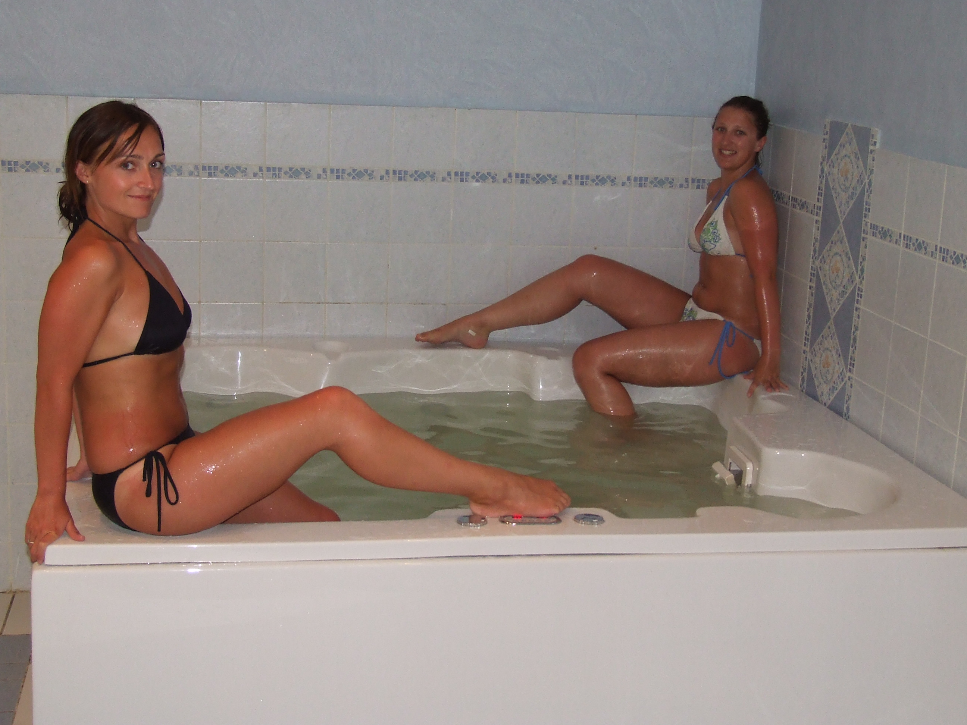
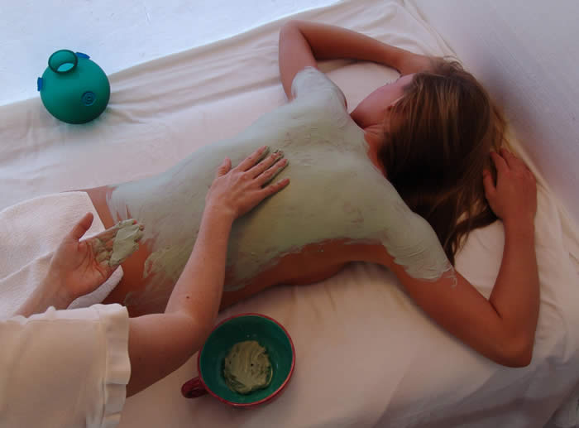
-Jacuzzi

-Calomille Body Mask

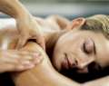
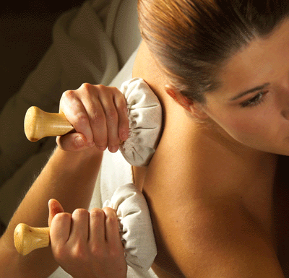
-Ice Towel

-Classic massage

(120 min)
550LE 100 $ 80€
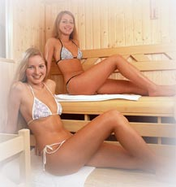

-Sauna

-Peeling Chocolate with bronze oil

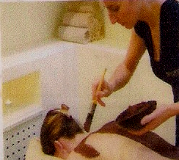

-Facial massage & soft mud
Egyptian massage 

