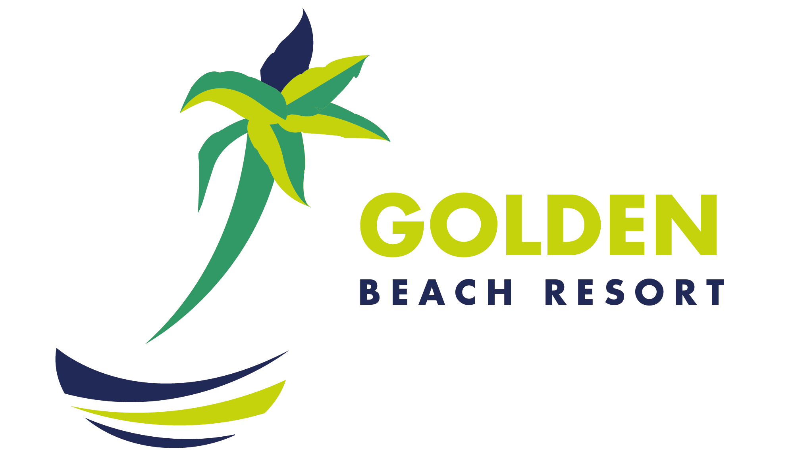



GENERAL HOTEL INFORMATION 2019

THE LOCATION:
GOLDEN BEACH Resort - Hurghada is located in a quiet location northwest of Hurghada directly on a wide and beautiful beach (bathing shoes recommended). El Gouna is approx 10Km away, and the center of Hurghada is approx. 15Km. To the International airport it is 20 Km.
THE RESORT:
GOLDEN BEACH Resort - Hurghada is consists of a main building and several adjoining buildings, lay in a lush palm tree garden with many exotic trees. A great choice for a beach vacation- specially for families (shallow water). Divers appreciate the diving center, which is located in the hotel premises. The popular hotel complex features an attractive pool area, one of the largest amphitheatres in the red sea, and many sport facilities.
The resort offers different types of comfortable accommodation (in total 456 spacious rooms) such as family rooms, double rooms with and without sea view as well as superior rooms. All rooms are equipped with airconditioning, telephone, Sat-TV, hairdryer and mini Bar.
The resort provides multiple choice of pools, 6 in total: Relax pool, Adults only pool, separate Kid’s pool and 2 pools connected by an artificiel river all the from the main building reaching the beach. «BLACK PEARL» Pirates Ship: our définition of water attraction with 5 different slides for adults and 3 for our beloved children. A horror room in the Ship's Belly is worth to be visited. WIFI avalable throughout all Hotel areas ( in the Lobby – free of charge ). Furthermore, the resort offers different sportactivities, fitness and wellness area, diving center, wind- and kitesurfing school, a mini club, own discothèque, shopping area, a Pier that leads to the wonders of the Red Sea, 7 Restaurants & 9 Bars.

ACCOMMODATION:
Standard Rooms – 128 ( 28m² ) 2 + 1 or 3 persons
Economy Rooms – 91 (16-24m² ) 2 persons
Superior Rooms – 36 ( 34m² ) 2 + 2 or 3 + 1child
Deluxe Rooms – 112 ( 28m² ) 2 + 1 or 3 persons
Sea View Rooms – 44 ( 24m² ) 2 persons
Connected Rooms – 12 ( 56m² ) 4 - 5 persons
Family Rooms – 14 ( 37m² ) 2 + 2 children

FOOD & BEVERAGE CONCEPT:
7 RESTAURANTS:
№ | Restaurants | Working Hours | Capacity
1. | «INDIANA JONES»  Main Restaurant / International Flair | Breakfast – Open Buffet : 07.00 – 10.00  Lunch – Open Buffet : 12.30 – 14.30  Dinner – Open Buffet : 18.30 – 21.00  ( during high occupancy ) | 400 seats
2. | «GREASE»  Fastfood | Continental Breakfast : 10.00 – 12.30  Fastfood : 12.30 – 07.00 | 150 seats
3. | «DON VITO»  A La Carte / Italian Flair | Dinner : 18.30 – 21.30 | 150 seats
4. | «ALADDIN»  A La Carte / Oriental Flair | Dinner : 18.30 – 21.30 | 80 seats
5. | «BUFFALO BILL»  A La Carte /  Meat / Chicken Specialties | Dinner : 18.30 – 21.30 | 200 seats
6. | «OO7»  A La Carte / Seafood Specialties | Dinner : 18.30 – 21.30 | 150 seats
7. | Lounge «OCEAN'S 11»  A La Carte / Star's Set Menu | Dinner : 18.30 – 21.30 | 85 seats

9 BARS:
№ | Bars | Working Hours
1. | «RICK'S» Bar - Non Smoking Bar Lobby Bar / Soft Beverages Only /  Tea/Coffee & Pastries | 10.00 – 00.00
2. | «ADULTS ONLY» Bar - Lobby Bar | 17.00 – 00.00 ( winter season only )
3. | «CELEBRITIES» Bar - Lobby Bar / Party Time | 17.00 – 00.00
4. | «OO7» Bar - Вeach Вar  Snacks / Tea/Coffee and Pastries | 10.00 – 18.00 ( winter season )  10.00 – 00.00 ( summer season )  Snacks : 12.30 – 14.30  Tea/Coffee & Pastries : 15.00 – 17.00
5. | «I-SCREAM» Cafe - Ice - Cream Cafe / Tea/Coffee & Pastries | 15.00 – 18.00
6. | «DOLCE VITA» Bar -  Pool Bar | 10.00 – 18.00
7. | «COYOTE UGLY» Bar - Pool Bar / Teens Cafe | 10.00 – 18.00
8. | «VITAMIN» Bar - Pool Bar / Fresh Juice & Fruits Ice-Cream | 10.00 – 18.00  Not included in UAI Concept
9. | «SPARKS» Disco -  Discotheque & Bar | After the Show – Approximately : 23.00 – 02.00 hrs.  Beverages are not included in UAI Concept ( Entrance free )

ACTIVITIES:
Sport | Games | Fitness | Water-Sport Activities/  Courses / Trips
- Beach Volley (2 Volleyball Fields)  - Tennis (3 Courts : Light/Equipment rent - against charge )  - Beach Football  - Water Polo | - Table Tennis  - Badminton  - Darts  - Frisbee  - Mini Golf  - Chess  - Backgammon  - Giant Chess  - Billiard  (against charge)  - Pool / Beach  Games | - Aerobics  - Step Aerobics  - Power Aerobics  - Stretching  - Aqua Gym  - Jogging  - Yoga  - Gym (Fitness Room free of charge) | - «BLACK PEARL» : Pirates Ship / Aqua Slides  - Вanana Boat  - Speed Boat  - Glass Boat  - Diving (trips & courses)  - Snorkeling (sea trips)  - Kite surfing (courses)  - Wind surfing (courses)  P.S.: Equipment rent, courses, sea trips are against charge

SPA: WELLNESS CENTER & BEAUTY SALON:
Oasis of Relaxation and Wellness with different kinds of Massage treatments, Sauna, Jacuzzi, Turkish Steam Bath, Hairdresser Services (cutting, styling, hair coloring, rasta ), manicure, pedicure, waxing. All Spa Center services are against charge

ENTERTAINMENT:
« GOLDEN BEACH » Assets | Party Time | Show Time | Chillout
- Cinema & 3D Cinema  - Labyrinth Garden  - «BLACK PEARL» Pirates Ship / Aqua Slides | - After Show  - Beach Party  - Pool Party  - Late- Night- show  - Oscar Awards | - Spectacles  - Music hall  - Cabarets  - Revues | - Music Compilation

KID'S WORLD:
Mini Club ( from 4 – 7 years ) | Junior Club ( from 8 – 12 years )
- Puzzle  - Reading session  - Coloring  - Special programs  - Playground  - Daily Kid’s Cinema (3D)  - Kid’s Dinner  - Mini Disco  P.S.: Children accompanied by a Member of our «Entertainment Team» | - Different types of games  - Tournaments  - Circle Games  - Puzzle  - Daily Kid’s Cinema (3D)  - Mini Disco  P.S.: Children accompanied by a Member of our «Entertainment Team»

MISCELLANEOUS:
- Smoking and Non Smoking Rooms are available.
- Smoking Area on the outside terrace of the Restaurants.
- Some activities will only be held if there are enough participants.
- During the pre-season and post-season, the activities offered may be limited due to
the weather.
- Depending on outside temperatures and the weather situation, the air-conditioning
may only be turned on when needed.

Additional amenities available for a fee:
- Doctor (on call by Reception)
- Taxi Service
- Fax Service
- Photo Service
- Laundry Service
- Shops
- Water Sports Stations
- Various Courses
- Beauty Center
- Hair Dresser
- Excursions
- Internet Services

Beach / Pool services free of charge:
- Showers
- Changing Cabin
- Sun Beds
- Umbrellas
- Beach towels ( against deposit )
- Beach quiet zone
- Quiet pool
Safety Deposit Box
- Safety Deposit Box is available in all room catégories, free of charge

