
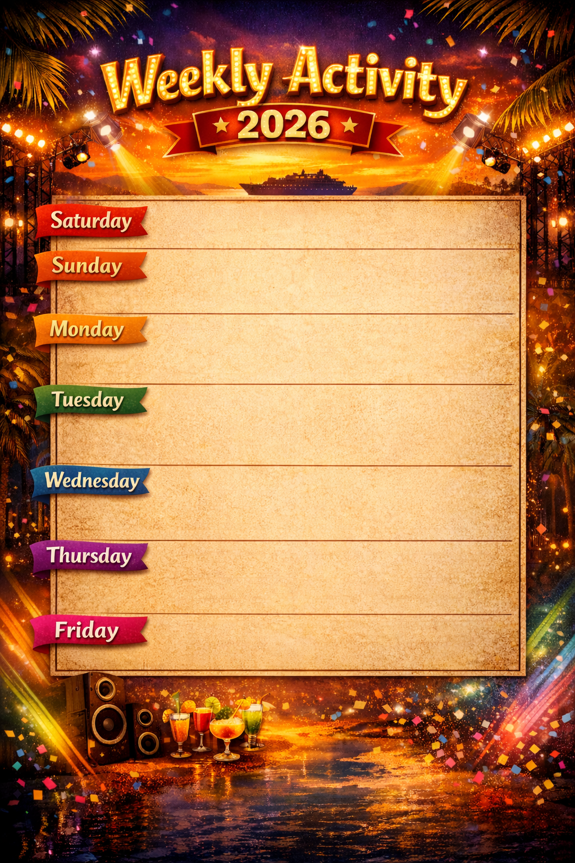

 | Disco Party | 20.30 | Disco
 | Live Music  Kids Show  Mr. Titanic | 20.30  20.30  21.30 | Lobby Bar  Disco  Disco
 | Kids Show  Circus show | 20.30  22.00 | Disco  Disco
 | Olympic Day  Live Singer  Kids Show  Men VS Woman | 11.00  20.30  20.30  21.30 | Beach Area  Lobby Bar  Disco  Disco
 | Games Show  Live Singer  Kids Show  MRS. Titanic | 11.30  20.30  20.30  21.30 | Swimming Pool  Lobby Bar  Disco  Disco
 | Foam Party  Festival Cocktails  Live Singer  Kids Show  Light Show | 11.30  11.30  20.30  20.30  21.30 | Swimming Pool  Pool Bar  Lobby Bar  Disco  Disco
 | Kids Show  Oriental Show | 20.30  21.30 | Disco  Disco

