**Aqua Park Fact Sheet**

|  |  |
| --- | --- |
| **Contacts:** |  |
| Address: | Makadi Bay, P.O. Box 623, Hurghada, Red Sea, Egypt |
| Telephone number: | +20 65 3590390/99 |
| Fax number: | +20 65 3590402 |
| Resort e-mail address: | royal.makadi@sunrise-resorts.com |
| Reservation e-mail: | [reservation.rm@s sunrise-resorts.com](BLOCKED::mailto:reservation.rm@sunrisehotels-egypt.com) |
| General Manager: | Said El Atiek |
| General Manager e-mail | Said.atiek[@s](mailto:sami.kaplanci@shedwanresort.com)unrise-resorts.com |

SUNRISE Select Royal Makadi Aqua Park is the latest fun-filled addition to Sunrise Select Royal Makadi Resort & Aqua Park, Featuring 18 different slides for both kids and adults including a free-fall slide, tube slides, multi slide, body slide & Black Hole Slide, Tube free fall slide, Wide Slide, Kamikaze Slide,Tube Kamikaze Slide, Rafting Slide, mini Aqua Park includes Octopus slides, and it is the best outing for the entire family.

To provide you with a second to none complete experience; savor as much as you can at our self service bar offering a wide variety of local soft drinks, sandwiches, pizzas, pasta and other mouth-watering light snacks that will surely appeal to you and your kids. In addition to ice creams variety.

**Operation Hours:**

* The aqua park is open from 10:00 a.m. until 12:00 and from 14::00 until 16:00
* The beverage bar is open from 10:00 a.m. until 17:00 p.m.
* The snack bar is open from 12:00 a.m. until 5:00 p.m.

**Age Restriction:**

Each water slide has its own age and height restriction.

**For outside guests:**

* Day Use per Adult Per Person US$35.00
* US$20.00 per Child per entry { 4 -12 years old }
* Above rates based on Soft All-inclusive without room

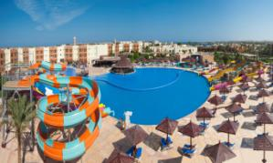

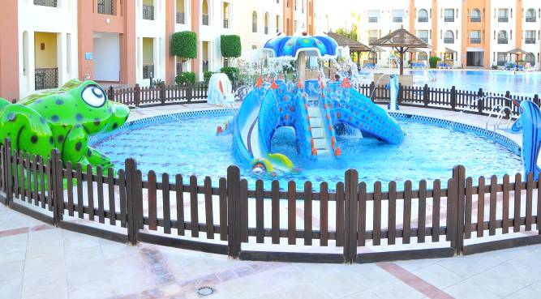

|  |  |  |  |
| --- | --- | --- | --- |
| H:\SUNRISE MAKADI AQUA PARK\0 (47).jpg | H:\SAID\صور اكوا الفامبلى\MIS_72100.JPG | H:\SUNRISE MAKADI AQUA PARK\New Folder\0 (28).jpg | H:\SUNRISE MAKADI AQUA PARK\New Folder\0 (31).jpg |
| H:\SUNRISE MAKADI AQUA PARK\0 (44).jpg | H:\SUNRISE MAKADI AQUA PARK\0 (43).jpg | H:\SUNRISE MAKADI AQUA PARK\New Folder\0 (23).jpg | H:\SUNRISE MAKADI AQUA PARK\New Folder\0 (21).jpg |
| H:\SUNRISE MAKADI AQUA PARK\New Folder\0 (20).jpg | H:\SUNRISE MAKADI AQUA PARK\New Folder\0 (22).jpg | H:\SUNRISE MAKADI AQUA PARK\New Folder\0 (25).jpg | H:\SUNRISE MAKADI AQUA PARK\New Folder\0 (30).jpg |
| H:\SAID\صور اكوا الفامبلى\MIS_7244.JPG | H:\SAID\صور اكوا الفامبلى\MIS_7215.JPG | H:\SAID\صور اكوا الفامبلى\MIS_7213.JPG | H:\SAID\صور اكوا الفامبلى\Copy of MIS_7250.JPG |
| H:\SUNRISE MAKADI AQUA PARK\New Folder\0 (5).jpg | H:\SAID\صور اكوا الفامبلى\MIS_7248.JPG | H:\SAID\صور اكوا الفامبلى\MIS_7214.JPG | H:\SUNRISE MAKADI AQUA PARK\New Folder\0 (15).jpg |
| H:\SUNRISE MAKADI AQUA PARK\New Folder\0 (2).jpg | H:\SUNRISE MAKADI AQUA PARK\New Folder\0 (18).jpg | H:\SUNRISE MAKADI AQUA PARK\New Folder\0 (1).jpg | H:\SUNRISE MAKADI AQUA PARK\New Folder\0 (26).jpg |
| H:\SUNRISE MAKADI AQUA PARK\New Folder\0 (4).jpg | H:\SUNRISE MAKADI AQUA PARK\0 (43).jpg | H:\SUNRISE MAKADI AQUA PARK\0 (36).jpg | H:\SUNRISE MAKADI AQUA PARK\0 (34).jpg |

**Aqua Park Slides specifications**

|  |  |  |
| --- | --- | --- |
| **Slide Name** | **Slide Photo** | **Specifications** |
| **Tube Slide** | 1.JPG | Height: 5.0m  Length:35m  Age: +10 |
| **Free Fall Slide** | 3.JPG | Height:5.0m  Length :24m  Age: +10 |
| **Multi Slides ( 4 lanes)** | untitled.JPG | Height:5.0m  Length : 24m  Age: +10 |
| **Body Slide** | H:\AQUA PARK ROYAL MAKADI OCTOBER 2014\SMALL\DSC_0195.jpg | Height:5.0m,  Length:35.0m  Age: +10 |
| **Black Hole Slide** | 2.JPG | Height:6.80m  Length:58m  Age: +10 |
| **Tube free Fall** | 4.JPG | Height:5. 0m  Length:24.0m  Age: +10 |
| **Multi Slide** | 5.JPG | Height:5.0m  Length:34.40m  Age: +10 |
| **Wide Slide** | 1.JPG | Height:5 . 0m  Length:24.0m  Age: +10 |
| **Kamikaze Slide** | 1.JPG | Height:5.0m  Length:24m  Age: +10 |
| **Tube Kamikaze Slide** | DSC_0137.jpg | Height :5.0m  Length: 24 m  Age: +10 |
| **Rafting Slide** | 1.JPG | Height:6.80  Length : 53m  Age: +10 |

**Kids Aqua Park**

|  |  |  |
| --- | --- | --- |
| **Slide Name** | **Slide Photo** | **Specifications** |
| **Octopus Slide** | H:\SAID\صور اكوا الفامبلى\Copy of MIS_7216.JPG | 6.5 m X 6.35 m X 3.0 m  Age -10 |
| **Rabbit Slide** | H:\SAID\صور اكوا الفامبلى\MIS_7215.JPG | 108 cm X 104 cm X 2.35 m  Age -10 |
| **Dolphin Slide** | H:\SAID\صور اكوا الفامبلى\MIS_7250.JPG | 75 cm X 120 cm  Age -10 |
| **Dolphin Slide** | H:\SAID\صور اكوا الفامبلى\MIS_7250.JPG | 75 cm X 120 cm  Age -10 |
| **Frog Slide** | H:\SAID\صور اكوا الفامبلى\MIS_7214.JPG | 165 cm X 2.5 m X 2.5 m  Age -10 |