

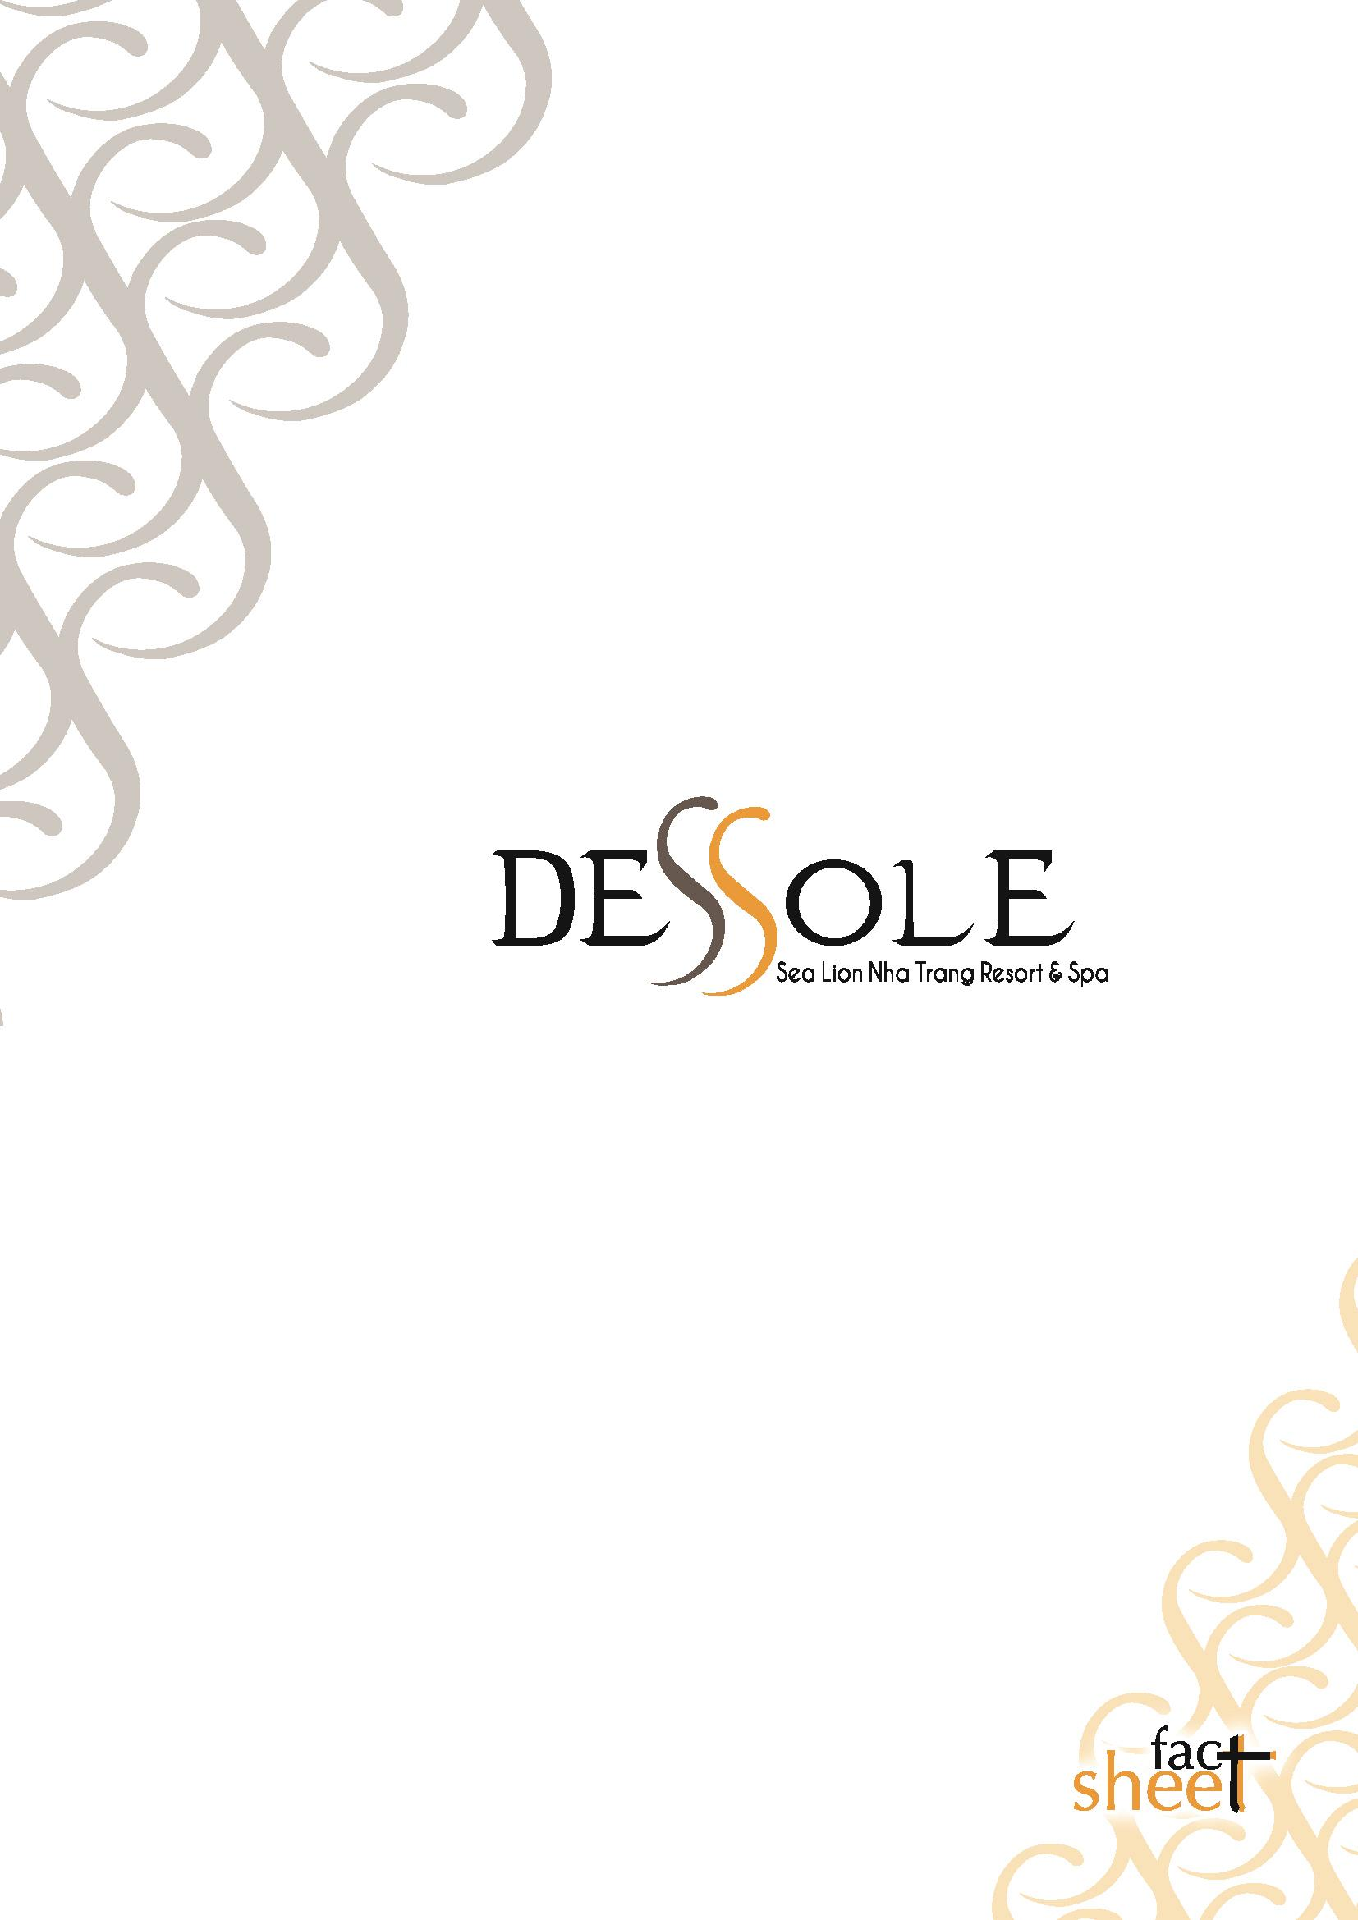

Address : Seti Sharm Palm Beach Resort Sharm El Maya Bay, Sharm El Sheikh, South Sinai, Egypt
Tel : +2 069 3666768 -777
Fax : +2 069 36 60 877
web : www.pegasegypt.com
e-mail : reservation.setisharm@pegasegypt.com
Official Category : 4 star
Concept : All inclusive
Renovation Date : 2009 Room furniture - Main restaurant - Superior Bathrooms
Area : 26.000 m²
Valid credit cards : VISA, MasterCard, Amex
Languages : English, German, Russian
C/out & C/in time : C/out time 12:00, C/in time : 14:00
Pets : Not allowed

Address : Km No11, Nguyen Tat Thanh Boulevard, Bai Dai Beach, Cam Lam
District, Nha Trang City, Khanh Hoa Province, Viet Nam
Tel : +84 058 3989700
Fax : +84 058 3989701
web : www.dessolehotels.com
e-mail : reservation.sealion@dessolehotels.com
Official Category : 4+ star Concept : All inclusive Construction Date: January 2014
Area : 32.500 m²
Valid credit cards : VISA, MasterCard
Languages : English, Russian
C/out & C/in time : C/out time 12:00, C/in time : 14:00
Pets : Not allowed

Location
The magnificent Dessole Sea Lion Beach Resort sits like an exotic jewel on Bai Dai Beach. The resort has superior accommodations, 300 rooms with terraces or balcony including 14
Bungalow, 18 Family Front Sea View rooms, 258 Standard Sea View rooms and 10
Standard Triple Sea View rooms. Rooms are settled in 12 floors building. The resort offer delicious buffets in all inclusive concept.

Distance:
Cam Ranh Airport : 3km / Transfer Time 8 Min
Nha Trang City : 27km/ Transfer Time 25 Min

Rooms
Total number of rooms : 300 rooms
Total capacity of beds /pax : 600 pax
Room blocks are comprised of 11 floors and 16 bungalows. Balcony height is 120 cm.

 | Bungalow | Family Front  Sea View | Standard Sea  View | Standard Triple  Sea View
Number of room | 14 | 18 | 258 | 10
Square (m2) | 57 | 45 | 38.7 | 36
Max occupancy | 3 | 3 | 3 | 3
Balcony | x | x | x | x
WC | x | x | x | x
bath room | x | x | x | x
Shower | x | x | x | x
bath Tub | x | x | x | x
Hair dryer | x | x | x | x
Telephone | x | x | x | x
Mini Bar | x | x | x | x
Safe box | x | x | x | x
TV satellite | x | x | x | x
Connecting door | N/A | some of them | some of them | N/A
Towel turn | daily | daily | daily | daily
Sheet Turn | every other day | every other day | every other day | every other day
Room cleaning | daily | daily | daily | daily
Beach Towel | every 3rd day | every 3rd day | every 3rd day | every 3rd day

Free Of Charge Services
Food, local & standard alcoholic drinks, mini bar (refilled daily with fruit juice (2), pepsi(1) and mineral water(1), safe deposit box (in the room), daily sport facilities & night show, table tennis, volley ball, mini club, beach towels changed in the beach towel station every 3rd day, umbrella
and sun beds by pool and on the beach, wireless internet connection all round the hotel.

Paid Services
Shuttle bus, fresh fruit juice, medical services, water sports, laundry, dry cleaning (ironing), baby sitter, telephone, fax, shops, sauna, steam bath, massage, water pipe and equipments. Lost and damage of guest room key.
.

Pools |  | Min – Max | Square
Oval pool | fresh water | 80 cm / 170 cm | 600 m2
Kids pool | fresh water | 80 cm | 70 m2
Sea-view pool | fresh water | 80 cm / 170 cm | 540 m2
Kids pool | fresh water | 80 cm | 72 m2

*Pools closed at sunset

Beach
Beach
Sandy beach
Length of sand beach: 310 m
Sunbeds, mattress, umbrella

Main Restaurant offering open buffet Breakfast, Lunch and Dinner. Snack service at Pool bar and 2 available bars.

Food Services  Hours | Services | Restaurants
06:30-10:00  10:00-11:00 | Breakfast / Open Buffet  Late Breakfast / Open Buffet | Main Restaurant  Main Restaurant
10:00-16:00  12:30-14:30 | Snack service  Lunch / open buffet | Pool Bar  Main Restaurant
14:30-16:00  16:00-16:30 | Seasonal fruits, corn, pop corn, croquettes  Tea & Coffee time | Pool Bar  Pool Bar
17:00-18:00  18:30-21:00 | Baked & apple slice potato  Dinner / Open Buffet | Pool Bar  Main Restaurant
22:30-06:30 | Tea & Coffee Time | Lobby Bar

Bars  Hours | Services | Bars
10:00-01:00 | Alcoholic & non alcoholic drinks | Pool Bar

Restaurant & Bar Capacity
Restaurant indoor (pax) outdoor (pax) Sea Lion Restaurant 250 150

Bars | indoor (pax) | outdoor (pax)
Lobby Bar  Pool Bar | 100  N/A | N/A  140

*Opening and closing times of the restaurants and bars can be changed according to season and weather conditions.
Entertainment & Activities

Day Activities : Morning gymnastic, step aerobics, aero relax, water gymnastic, stretching, beach volley, beach dance, beach game, club dance, dart game on pool, water polo, pool game, pool dance, table tennis, boccia ball, cards, dance lessons, latin salsa, belly dance, tango Cha Cha Cha, R&B dance, tournament and organizations.

Night Activities : Night show programs, competition, sketch and playback nights, popular and famous dance shows, beach and pool party.

Mini Club : Kids age between 04 - 12, 10:00-11:50 / 14.30-17:00

Baby Sitter : Babysitting service is available for children younger than 02 years. Reservation is required 12 hours before. (extra paid)

Water Sport (extra) : Jet ski, Banana boat, Parasailing, Water ski, Fishing trip, Catamaran, Speed boat rental, Body board, Surfing board, Kayaking, Kite surfing, Wind surfing, Rowing board, Snorkelling, Diving Service

Land Sports : Beach volley ball, table tennis, kids club & children’s playground, 1 water ball, 2 darts, aerobic and dance floor.

SPA Center : Open between 09:00 – 21:00 for sauna - steam bath, massage are all extra services

Security Fire Exits Warning signs
Height of balcony is 90 cm. Signboards around the pools Lifeguards at the pools and beach

Useful Information
• All swimming pool and beach activities are subject to weather conditions.
• Smoking is not allowed in closed areas.
• Alcoholic drinks are restricted to ages under 18.
• All restaurants serve beverages in glasses – serving in bottles is against hotel policy
• All imported beverages have been legally brought into the country.
• Schedules and venues for outdoor events are subject to weather conditions.
• Dessole Resorts reserves the right to make changes without prior announcement.
• The hotel management is fully authorized to make amendments and/or cancellations regarding any aspect of the services offered. If and when such changes are made,
the now-irrelevant information in the catalogue will be construed as simultaneously reflecting the changes made.

