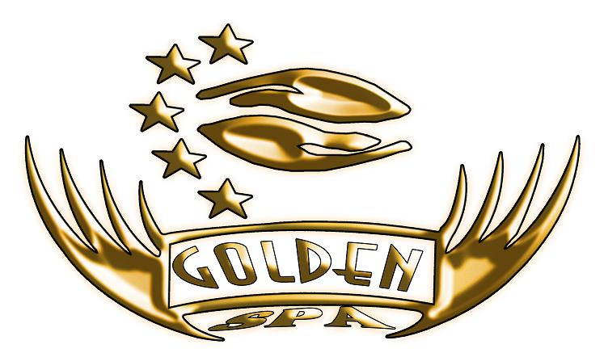

600LE 110 $ 90€
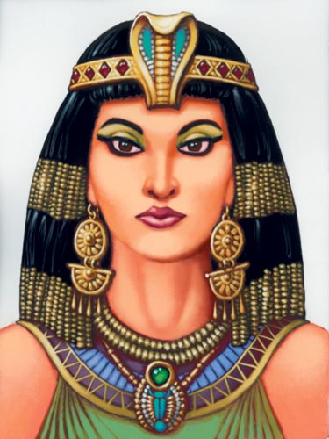
- Sauna (120 min)
-Jacuzzi
-Coffee (full body peeling)
Or
-Coconut (full body peeling)
Or
-Mineral Red Sea salt (full body peeling)
-Face mask
-Full body massage

600LE 110 $ 90€
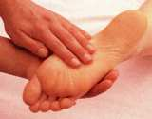
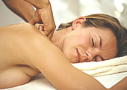
-Foot reflexology (120 min)

-Full body massage
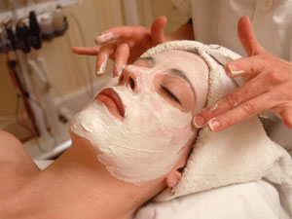
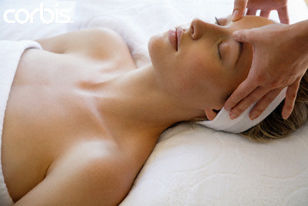
-Indian head massage

-Face massage

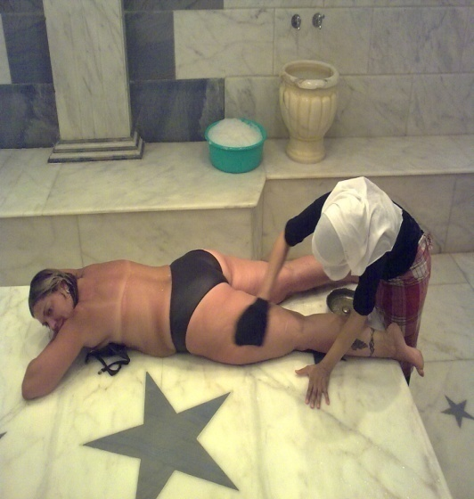
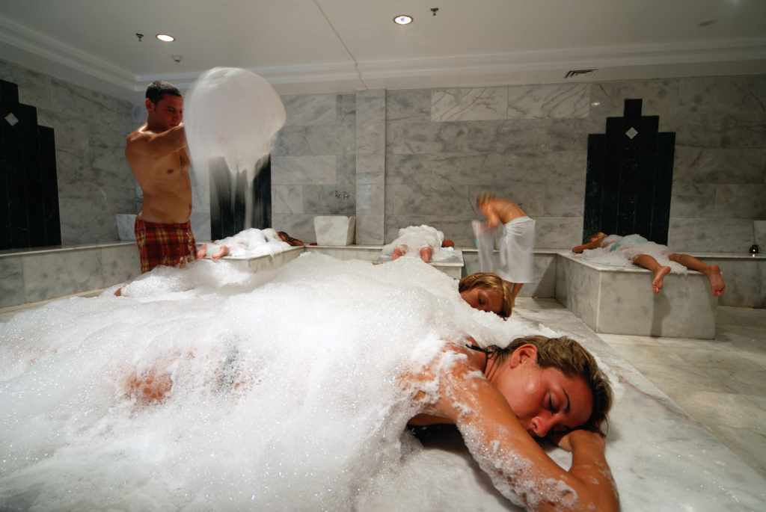
600LE 110 $ 90€
(120 min)
-Turkish bath program

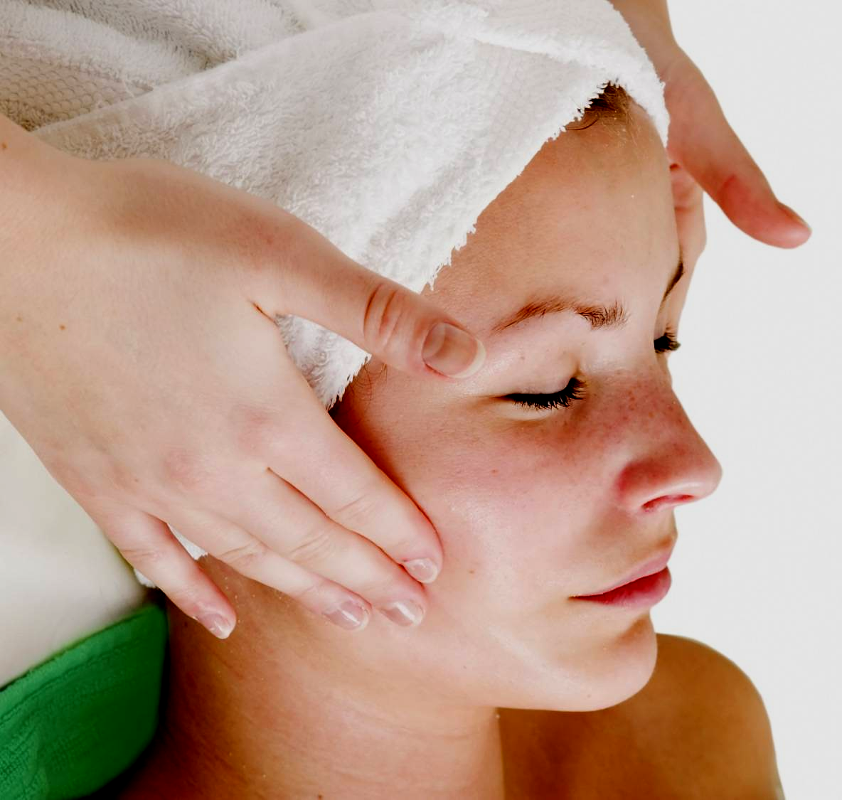
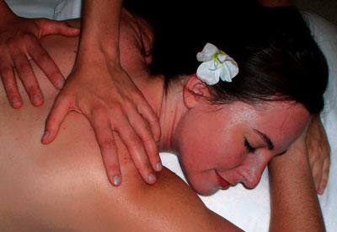
-Full body massage

-Face mask and face massage

