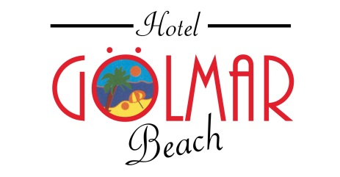

GENERAL INFORMATION
Address: | Kayabal Cad.No:69 İçmeler Marmaris MUĞLA
Telephone: | +90 (0252) 455 31 89
Fax: | +90 (0252) 455 39 27
Web: | www.hotelgolmarbeach.com
E-mail: | reservation@hotelgolmarbeach.com , golmar@hotelgolmarbeach.com
Board : | ALL INC. (Details are below) concept is between 10:00 to 22:30.
Voltage: | 220 V
Pets: | No Pets Allowed
Payment Terms: | EURO CARD, MASTER CARD, VISA, CASH
DISTANCE FROM HOTEL
Dalaman Airport : | 105 Km |  |  | Beach / Sea : |  |  | On the beachfront
Marmaris Bus Station : | 10 Km |  |  | Wednesday Market : |  |  | 1 km
 |  |  |  | Minibus Stop : |  |  | 35 m
Marmaris Central ; | 8 Km |  |  | İcmeler Harbour : |  |  | 25 m
Icmeler Central ; | 500 meters
ACCOMMODATION
Room Type: | Shower |  |  |  | Hair Dryer
 | Telephone |  |  |  | Television
 | Balcony |  |  |  | Minibar
 | Air Conditioning |  |  |  | Carpet
Check in: | 14.00
Check out: | 12.00
Capacity: | 170 oda | 30 One Bedroom Family Rooms | 140 Standard Rooms  Standard rooms; Twin Beds or Double Bed (Additional Folding bed if required)  Family Rooms; Twin Beds and Double Bed  Std Rooms are 20m2 – 23m2 Family rooms are 30 m2 – 32 m2
Maid Services: | Room cleaning everyday ,Clean Towels and Linen every 2 days.
FOOD & BEVARAGE FACILITIES
BUFFET (OPEN BUFFET) | Breakfat, Luch and Dinner
A’ LA CARTE RESTAURANT (Extra) | 10:00 -24:00
A’la Carte BAR | 10:00 -22:30 in consept. From 22:30 till 24:00 extra
BREAKFAST (Open Buffet) | 07:30 – 10:00
LUNCH (Open Buffet) | 12:30 – 14:00
DINNER (Open Buffet)  Cookis & Tea Time | 19:00 – 21:00  17:00 -18:00
FACILITIES
Water Slide |  |  |  |  |  | Pool Table (Chargeable)
Childrens Pool | Safe Box |  |  |  |  | Table tennis
Outdoor Pool | Beach/ Free Sunbeds / Free Umbrella |  |  |  |  | Spa packages, sauna, Turkish bath  Fitness, sport activities
Playground | Otopark
Wi-fi (Lobby-Restaurant)

A’LA CARTE BAR: Enjoyable ambiance, live or DJ music, wide-open and indoor areas. Serving variety of hot and cold beverages, alcoholic drinks between 10:00 -22:30. From 22:30 extra chargeable.

IMPORTANT REMARKS
All local drinks, bottle wine, draft beer, soft beverages and hot drinks are included in the all inclusive concept. All inclusive concept is between 10:00 to 22:30.
All import beverages, frozen cocktails, special wines, fresh fruit juices, bottled beverages, cappuccino, espresso are excluded.
Hotel has the right to change the locations of the food & beverage services without prior
notice. Opening and Closing dates of the Restaurants might change due to weather conditions. No pets are allowed.

